Bahria University,

Karachi Campus



LAB EXPERIMENT NO.

___8___

LIST OF TASKS

|  |  |
| --- | --- |
| TASK NO | OBJECTIVE |
| 1 | Create a Porfolio |
| 2 | Create a shopping web of your choice. |

Submitted On:

20-06-2023

(Date: DD/MM/YY)

**Task#1: Create a Porfolio.**

GitHub Link:

<https://github.com/Talhazafar143/Portfolio>

Output:

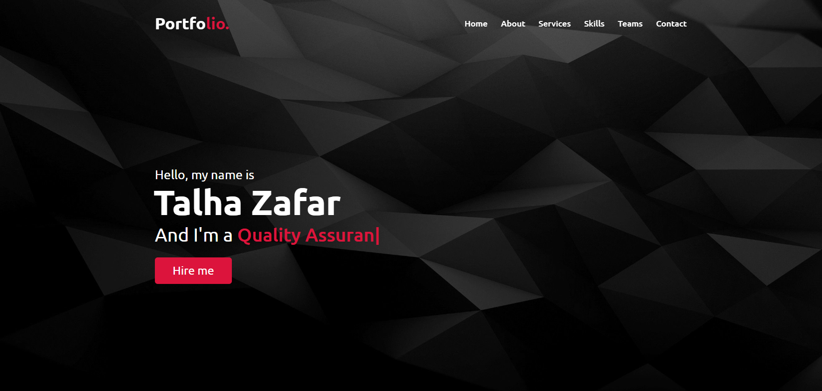

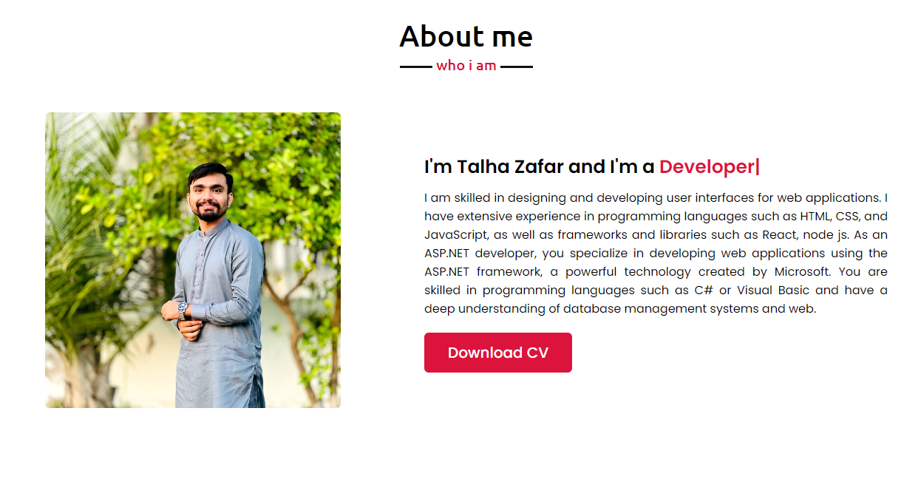

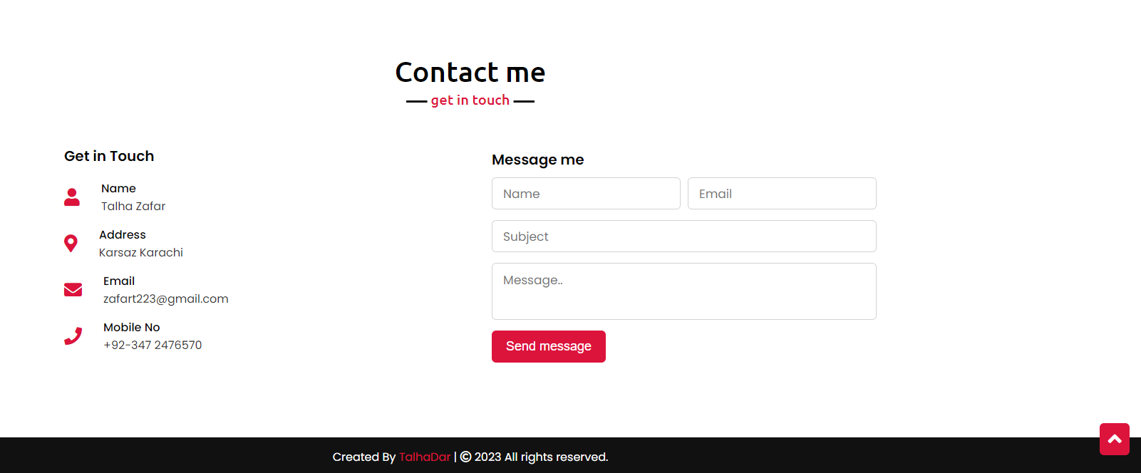

Task2: Create a shopping web of your choice.

Link: <https://react-e-commerce-2k22.web.app/>

Output:



